* **EDUTAINERS**

**Series – I Specialist of Sciences Date: 24/01/18**

**Bio T5 Ch # 2 (1st Half) 1st year Time:75min Marks:40**

**Name: _________________________ Objective**

***Question No. 1 A B C D***

|  |  |  |  |  |  |
| --- | --- | --- | --- | --- | --- |
| 1 | **Peptide bond is a** | N-H link | C-O link | C-H link | C-N link |
| **2** | **Animal obtained carbohydrates mainly from** | Glucose | Sucrose | Starch | glycogen |
| **3** | **Which of following monosaccharide is rare in nature and occur some bacteria** | Trioses | Tetroses | Pantoses | Hexoses |
| **4** | **Specific heat of vaporization of water is** | 374 Kcal/kg | 474 Kcal/kg | 574 Kcal/kg | 674 Kcal/kg |
| **5** | **Carbohydrate is about ____ % of total cell weight in bacterial cell** | 15 | 04 | 18 | 03 |
| **6** | **LACITHIN is** | Waxes | Triglyceride | phospholipid | terpenoids |
| **7** | **Which of following disaccharide give glucose and fructose on hydrolysis** | Maltose | Lactose | Sucrose | galactose |
| **8** | **Which of following is a oligosaccharide** | Glucose | Fructose | Sucrose | None |
| **9** | **Which of following is an unsaturated fatty acid** | Butyric acid | Oleic acid | Palmatic acid | Acetic acid |
| **10** | **How many proteins are present in human body** | 574 | 1000 | 10000 | 100000 |

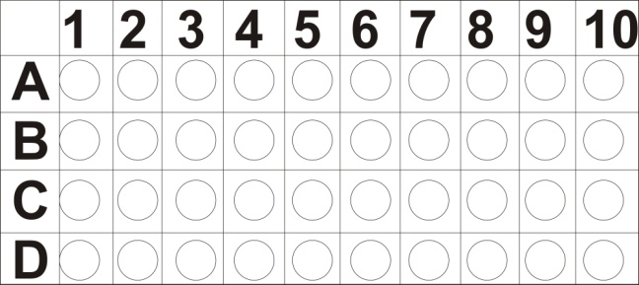

**Subjective**

**Q No 2: Short question (2 x 11 = 22)**

|  |  |  |
| --- | --- | --- |
| **1)** | How water is important for the protection mechanism in organism | **2)** Differentiate b/w starch and glycogen |
| **3)** | Write down structural formula of phosphatidylcholine | **4)** Draw structural formula of amino acid (alanine) |
| **5)** | What is glycosidic bond? | **6)** Define biochemistry and in which fields it is essential for understanding |
| **7)** | What is terpenoids? And how its important | **8)** Differ b/w animal fat and plant fat |
| **9)** | Write down the structural formula (A) ribofuranose (B) Glucopyranose | **10**) Differ b/w Anabolic and catabolic reactions |
| **11)** | What is cellulose? give a short note on its characteristics |  |

**Q no. 3: Subjective (Long Questions) (4 + 4 = 8)**

|  |
| --- |
| 1. Explain the importance of water. 2. Detailed note on amino acid   ا |